TimeSprite

Status Reports and Project Submissions

Date: 08/10/2015 to 15/10/2015

University of the Pacific

COMP 188, Senior Project, 2015 Fall ---Yunpeng Zhang

Contents

2 Project Schedule 2

3 Currents Status 3

3.1 Finished Tasks 3

3.2 Falling being schedule 3

4 Plan for next work period 4

4.1 Task for next work period 4

5 Challenges and concerns 5

6 updated artifacts 6

# Project Schedule

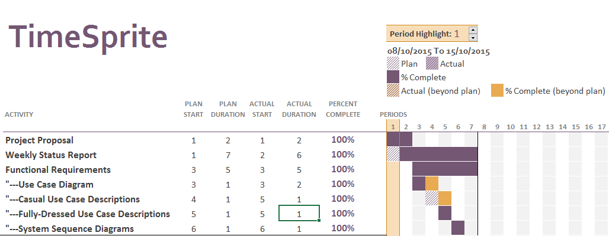

# Currents Status

## Finished Tasks

1. Project Proposal
2. Functional Requirements
   1. Use Case Diagram
   2. Casual Use Case Descriptions
   3. Fully-Dressed Use Case Descriptions
   4. System Sequence Diagrams

## Falling being schedule

* Use Case Diagram
  + It spent 2 days, one more day than plan. Because I did not finish the diagram. So it cost one more day

# Plan for next work period

## Task for next work period

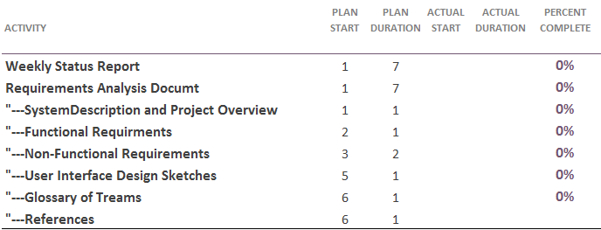

All tasks will be signed to Yunpeng Zhang.

# Challenges and concerns

It difficult to design the use case diagram, because this project has a lot user interaction. I need to consider lot situations. However, it only spent more time than plan, so it still acceptable.

# updated artifacts

I attached functional requirements documents. It will be a part of Requirements analysis documents.